Cricket Player Performance Tracking Application : CRICKSTATS

User Story:
As a Salesforce Admin, I want to create a comprehensive player performance tracking application within Salesforce to capture and analyze detailed match-by-match information of cricket players. This application will include custom objects such as Player and Match Performance with carefully defined fields and relationships to ensure data integrity and accessibility. By leveraging master-detail and lookup relationships, the application will enable robust tracking of individual and team performances, facilitate insightful reporting and analytics, and support the overall management of player statistics, thereby enhancing strategic decision-making and player development initiatives.

INTRODUCTION

Project Overview :

CRICKSTATS is a Salesforce-based application designed to track, manage, and analyze cricket players’ performance on a match-by-match basis. The system uses custom objects, relationships, dashboards, and automation tools to provide structured performance insights.

It enables coaches, analysts, and administrators to record player statistics, generate reports, and support strategic decision-making.

Purpose :

The main purpose of this project is:

To digitize player performance records

To improve accuracy and accessibility of cricket statistics To provide real-time analytics
To support player development and team planning To automate data management using Salesforce

IDEATION PHASE

Problem Statement (Customer Problem Statement Template)

Problem Statement (PS) | I am (Customer) | I’m trying to | But | Because | Which makes me feel
PS-1 | A cricket team coach | Track player performance across matches | I cannot get accurate statistics easily | Data is stored in different files and formats | Frustrated and unsure about team selection
PS-2 | A team manager | Maintain complete player records | It takes too much time to update and verify data | Most records are maintained manually | Stressed and inefficient
PS-3 | A sports analyst | Analyze player trends and generate reports | I face difficulty in comparing performance s | There is no centralized analytics system | Confused and dissatisfied

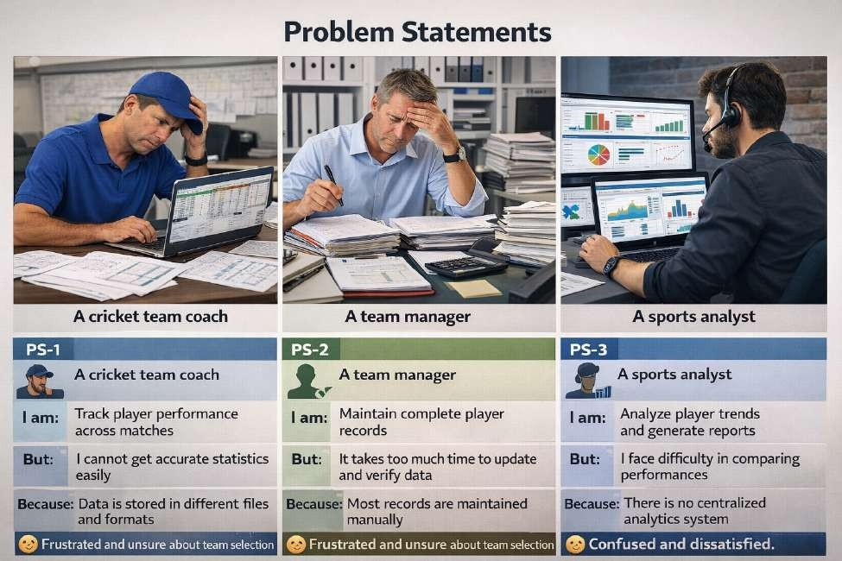

Empathy Map Canvas

Target Users
    - Team Managers
    - Coaches
    - Analysts
    - Salesforce Admins

Empathy Analysis
Aspect Description
    - Think & Feel: Need accurate data, better insights
    - Hear: Feedback from management
    - See: Multiple data sources
    - Say & Do: Collect statistics manually

    - Pain: Data errors, delays
    - Gain: Faster decisions, automation
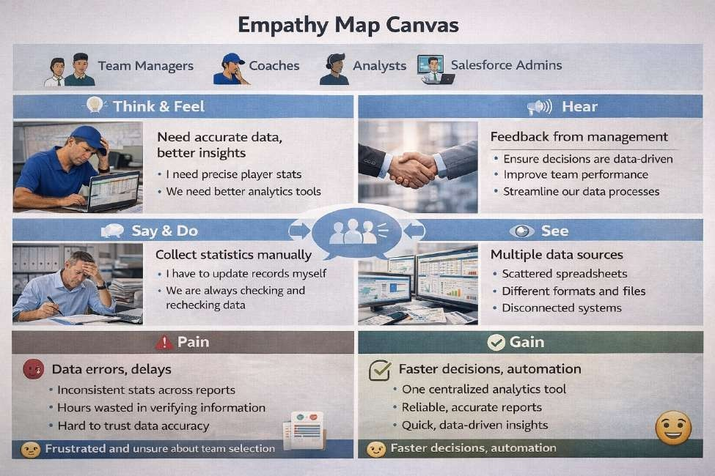

Brainstorming

Brainstormed Ideas
    - Web-based player management system
    - Mobile statistics tracker
    - Salesforce-integrated CRM
    - AI-based performance prediction
    - Dashboard-based analytics

Selected Idea: Salesforce-based performance tracking platform (CRICKSTATS)

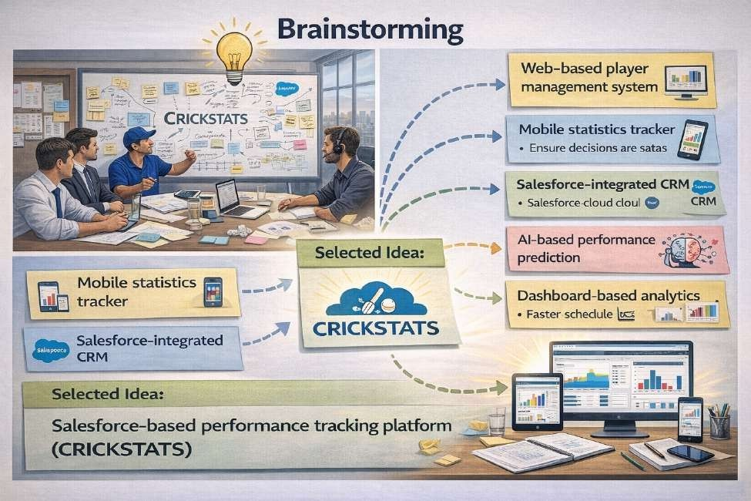

REQUIREMENT ANALYSIS PHASE

Customer Journey Map
Journey Stages:
    - Login
    - Enter Player Data
    - Record Match Performance
    - Generate Reports
    - Analyze Results
    - Decision Making

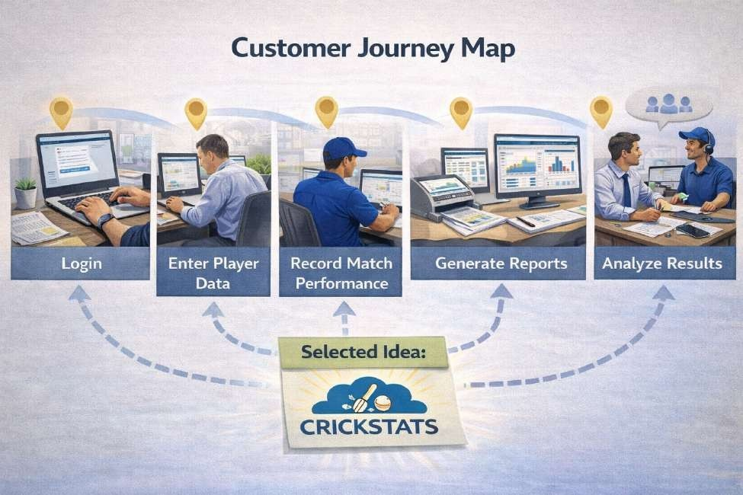

Solution Requirements

Functional Requirements

FR No | Requirement
FR-1 | Player Registration
FR-2 | Match Performance Entry
FR-3 | Dashboard Generation
FR-4 | Report Creation
FR-5 | Flow Automation

Non-Functional Requirements (NFRs) – CRICKSTATS

NFR-1: Usability
The system should be easy to understand and use by coaches, managers, analysts, and admins without requiring technical training.

Requirements
    - Simple and intuitive user interface
    - Clear navigation menus
    - Easy-to-read dashboards
    - Minimal learning curve

Examples:
    - A new coach should be able to:
    - Log in
    - Enter match data
    - View player reports
    - within a few minutes without special training.
Example: The Salesforce Lightning interface provides drag-and-drop dashboards and user-friendly forms.

NFR-2: Security
The system must protect sensitive player data from unauthorized access.

Requirements
    - Role-based access control
    - Secure authentication
    - Encrypted data storage
    - Regular backups
.

Examples:
    - Coaches can view player statistics
    - Managers can edit records
    - Analysts can generate reports
    - Only admins can modify system settings
Example: Salesforce Profiles and Permission Sets restrict access to confidential information.

NFR-3: Reliability
The system should function correctly without failure and store data accurately.

Requirements
    - No data loss
    - Automatic backups
    - Error handling
    - System stability

Example:
If a manager enters match statistics and loses internet connection, the data should be saved automatically when reconnected.
Salesforce cloud backup ensures recovery in case of system failure.

NFR-4: Performance
The system should respond quickly and handle large volumes of data efficiently.

Requirements
    - Fast page loading
    - Quick report generation
    - Smooth dashboard rendering
    - Minimal response time

Example:
When an analyst generates a performance report for 100+ players, the report should load within 2–3 seconds.
Optimized Salesforce queries and caching improve response speed.

NFR-5: Availability
The system should be accessible whenever users need it.

Requirements
    - 24/7 system availability
    - Minimal downtime
    - Cloud-based access
    - Disaster recovery

Example:
Coaches should be able to access CRICKSTATS even during tournaments at night or on weekends.
Salesforce provides high uptime with cloud hosting.

NFR-6: Scalability
The system should support increasing numbers of users, players, and records.

Requirements
    - Handle growing datasets
    - Support more teams and leagues
    - Expand storage capacity
    - Maintain performance under load

Example:

If CRICKSTATS is extended from one team to 50 teams, the system should still perform smoothly.
Salesforce cloud infrastructure automatically scales storage and processing.

Data Flow Diagram

Data Flow
User → Salesforce UI → Player Object → Match Performance → Reports → Dashboard

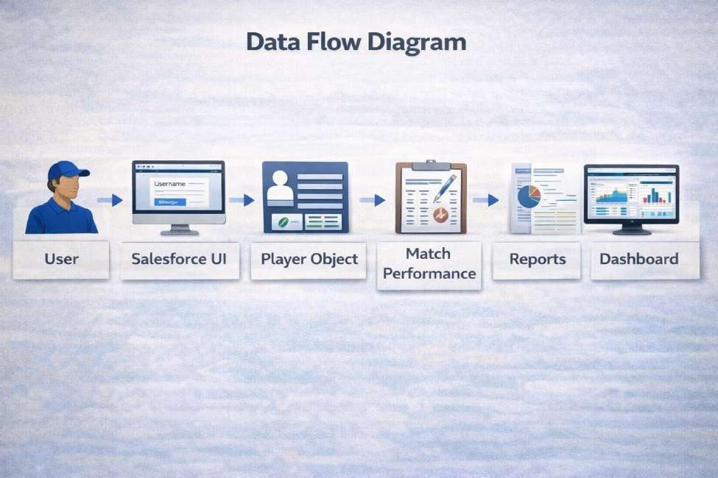

Technology Stack

Layer | Technology
Frontend | Salesforce Lightning
Analytics | Reports & Dashboards
Automation | Salesforce Flows
Backend | Salesforce Objects
Database | Salesforce Cloud

PROJECT DESIGN PHASE

Problem–Solution Fit
The CRICKSTATS system effectively addresses the key challenges faced in traditional cricket performance management. Earlier, most player and match data were maintained using manual records, which were time-consuming and prone to errors. This issue has been resolved by implementing an automated system through Salesforce, which ensures accurate and efficient data entry and management. The problem of data loss, caused by improper storage and lack of backups, is overcome by using secure cloud storage that safely stores all information and allows easy retrieval. Poor analysis of player performance, due to scattered and unorganized data, is addressed through interactive dashboards that present clear visual insights and reports. Additionally, delays in accessing performance information and generating reports are eliminated by providing real-time reporting features, enabling users to make faster and more informed decisions. Thus, CRICKSTATS successfully bridges the gap between existing problems and modern technological solutions.

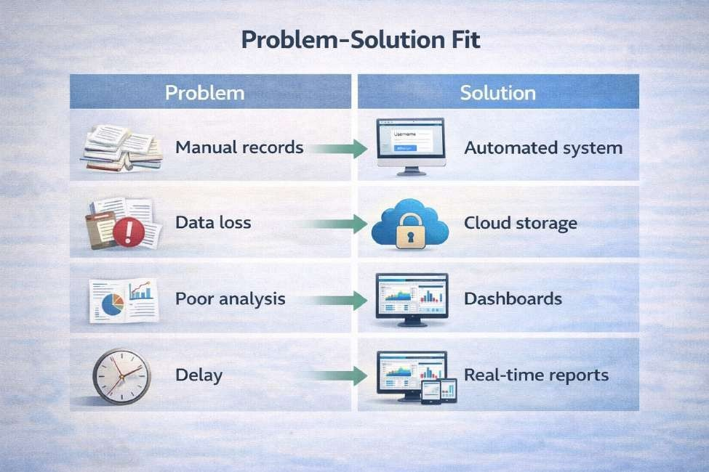

  - Proposed Solution Description CRICKSTATS provides:
    - Custom objects (Player, Match Performance)
    - Master-detail relationships
    - Roll-up summaries
    - Lightning App
    - Automated flows
    - Interactive dashboards

Key Features

    - Centralized database
    - Live statistics
    - Secure access

    - Scalable design
    - Easy reporting

Solution Architecture

Architecture Layers
    - Presentation Layer (Lightning UI)
    - Application Layer (Flows, Logic)
    - Data Layer (Objects)
    - Analytics Layer (Reports)
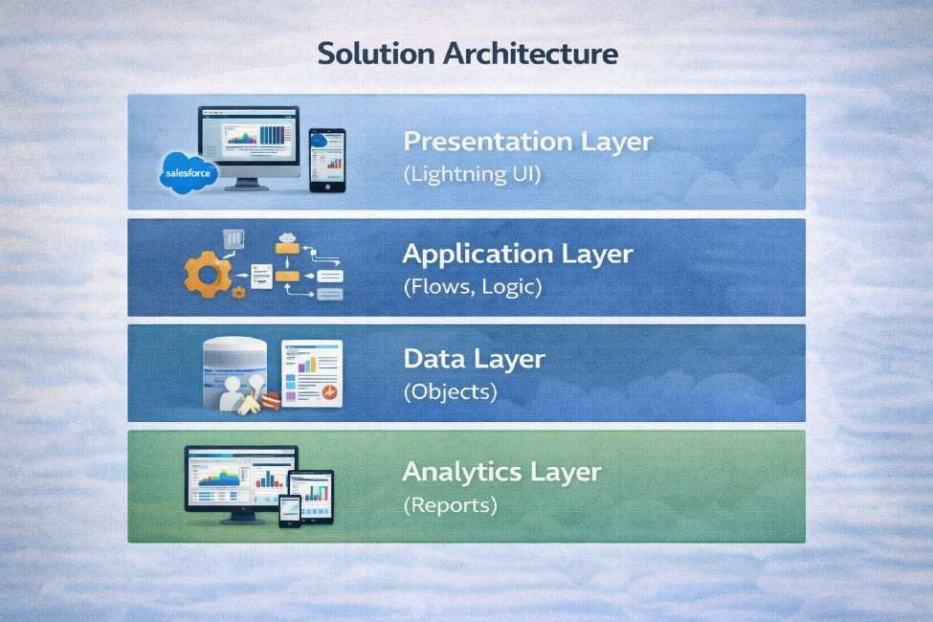

PROJECT PLANNING & SCHEDULING

Project Planning
    - Agile-based execution
    - Object creation → automation → reporting
    - Sprint-wise development
Product Backlog, Sprint Schedule, and Estimation (4 Marks)
Use the below template to create product backlog and sprint schedule

Sprint | Functional Requirement  (Epic) | User Story  Number | User Story / Task | Story Points | Priority | Team Member  s
Sprint-1 | Developer Setup | USN-1 | As an admin, I want to create a Salesforce developer account so that I can configure and deploy the  CRICKSTATS system. | 1 | High | Mohammed Aasif H
Sprint-1 | Data Modeling | USN-2 | As an admin, I want to create Player and Match Performance  objects so that player and match data can be stored systematically. | 3 | High | Muthamizhan S
Sprint-2 | Navigation | USN-3 | As a user, I want separate tabs for each object so that I can easily  navigate and manage records within the application. | 3 | High | Thamizh selvan v
Sprint-2 | UI Design | USN-4 | As a coach, I want a dedicated Lightning App so that all  performance tracking features are accessible from one dashboard. | 3 | High | Nithish s
Sprint-2 | Data Structure | USN-5 | As an admin, I want to create  player and match fields so that  complete performance details can be captured accurately. | 5 | Medium | Mohammed Aasif H
Sprint-2 | Data Structure | USN-6 | As a user, I want customized page layouts so that only relevant fields are displayed during data entry. | 5 | High | Spundhiraraj M
Sprint-2 | Automation | USN-7 | As a system, I want to validate player and match inputs so that incorrect data entries are prevented. | 3 | High | Soundhira raj M
Sprint-3 | Automation | USN-8 | As a system, I want automated flows to update player statistics so  that performance data remains accurate. | 5 | High | Mohammed Aasif H

Project Tracker, Velocity & Burndown Chart: (4 Marks)

Sprint | Total Story Points | Duratio n | Sprint Start Date | Sprint End Date (Planned) | Story Points Completed (as on  Planned End Date) | Sprint Release Date (Actual)
Sprint-1 | 20 | 6 Days | 13 Aug 2026 | 05 Sep 2026 | 20 | 05 Sep 2026
Sprint-2 | 20 | 6 Days | 07 Sep 2026 | 12 Sep 2026
Sprint-3 | 20 | 6 Days | 14 Sep 2026 | 19 Sep 2026
Sprint-4 | 20 | 6 Days | 21 Sep 2026 | 26 Sep 2026

- Project Development Phase:

Project Flow

Milestone 1 : Creation of developer account Milestone 2 : Object Creation
Milestone 3 : Tabs
Milestone 4 : The Lightning App Milestone 5 : Fields & Relationships Milestone 6 : Roll-up Summary Milestone 7 : Flows

Implementation

Milestone 1 - Salesforce developer account creation :

Activity 1: Creating Developer Account:

Creating a developer org in salesforce.
- Go to https://developer.salesforce.com/signup
- On the sign up form, enter the following details :
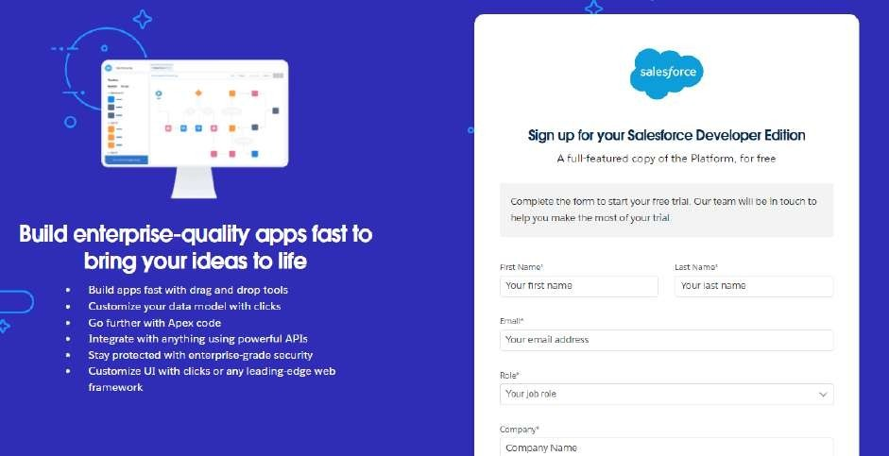

  - First name & Last name
  - Email
  - Role : Developer
  - Company : College or Company Name
  - County : India
  - Postal Code : pin code
  - Username : should be a combination of your name and company This need not be an actual email id, you can give anything in that format : username@organization.com
Click on sign me up after filling these.

Activity 2: Account Activation :

- Go to the inbox of the email that you used while signing up. Click on the verify account to activate your account. The email may take 5-10mins.

- Click on Verify Account.

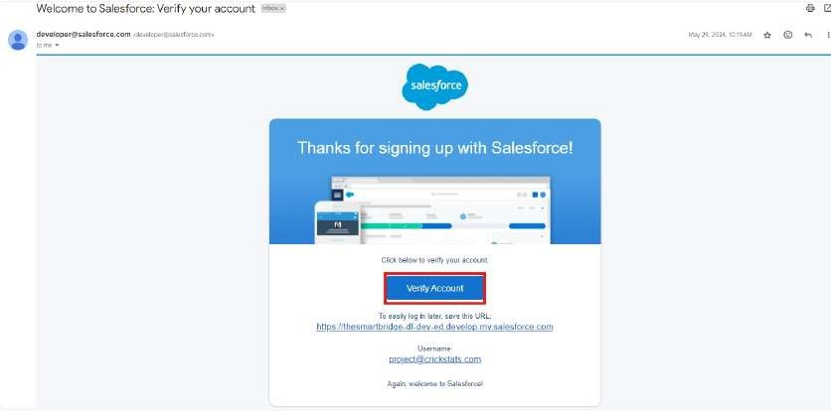

- Give a password and answer a security question and click on change password.
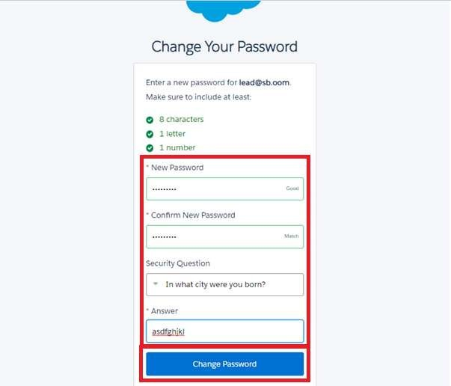

- Then you will redirect to your salesforce setup page.

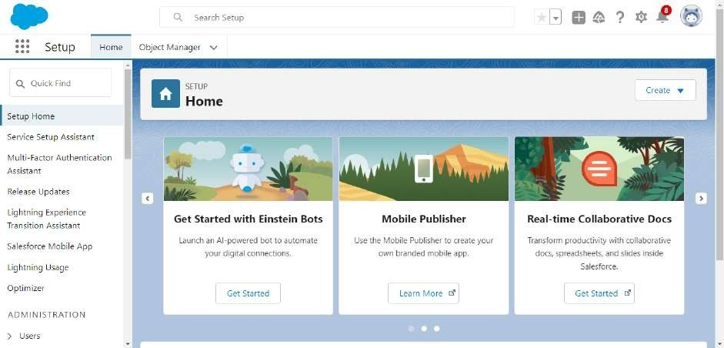

Milestone 2 - Object Creation Activity 1 : Player Object
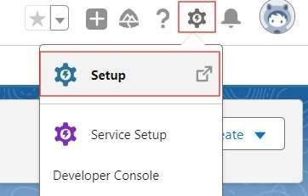
  - In your Salesforce org, click gear icon on the top left and select Setup to open Setup.

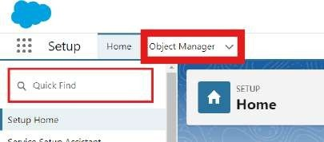
  - Click the Object Manager tab. If you don’t see it, enter Object Manager in the Quick Find box.

  - On the Object Manager page, click Create | Custom Object.

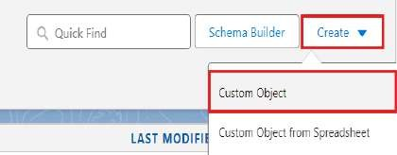

- From the setup page → Click on Object Manager → Click on Create → Click on Custom Object.
  - Label : Player
  - Plural Label : Players
  - Enter Record Name Label and Format Record Name : Player Name Data Type : Text
  - In Optional features : check the boxes for Allow Reports | Allow Activities
| Track Field History.
  - Search Status : check the box for Allow Search.
  - Save

Activity 2 : Match Performance Object

- From the setup page → Click on Object Manager → Click on Create → Click on Custom Object.
  - Label : Match Performance
  - Plural Label : Match Performances
  - Enter Record Name Label and Format
Record Name : Customer Account Name Data Type : Text
  - In Optional features : check the boxes for Allow Reports | Allow Activities
| Track Field History.
  - Search Status : check the box for Allow Search.
  - Save.

Milestone 3 - Tabs
Activity 1 : Custom tabs creation

- Go to setup page → type Tabs in Quick Find bar → click on tabs → New (under custom object tab)
- Select Object(Player) → Select the tab style → Next (Add to profiles page) keep it as default → Next (Add to Custom App) uncheck the include tab .
- Make sure that the Append tab to users' existing personal customizations is checked.
- Click save.
- Repeat the same steps for Match Performances.
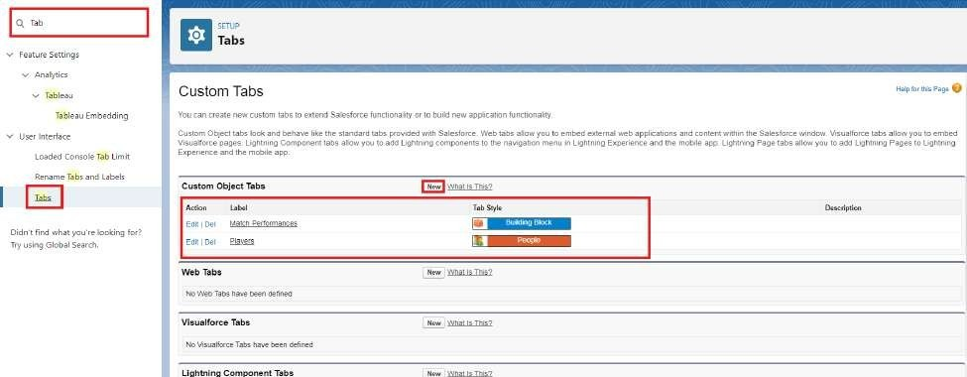

Milestone 4 - The Lightning App Activity 1 : Create a lightning app
- Go to setup page → search “app manager” in quick find → select “app manager”
→ click on New lightning App.

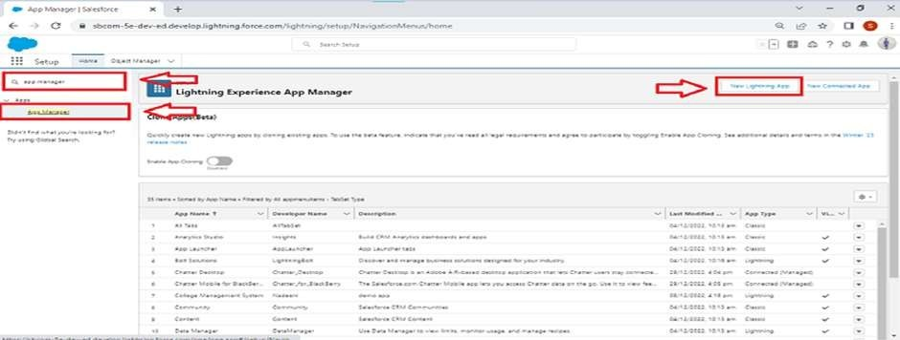

- Fill the app name in app details and branding as follow App Name : CRICKSTATS
Developer Name : Auto Populates
Add image optional (if you want to give any image you can otherwise not mandatory) - Add Primary color Hex or leave it to default.
Then click Next.

- In App options
Navigation style : Standard navigation Setup experience : setup
Supporters form factors : Desktop and phone Then click Next

- In Utility items
Utility Bar alignment : Default Then click Next.

- Navigation items
Select the created Custom Objects and required standard objects
  - Players
Match Performances Reports
Dashboards

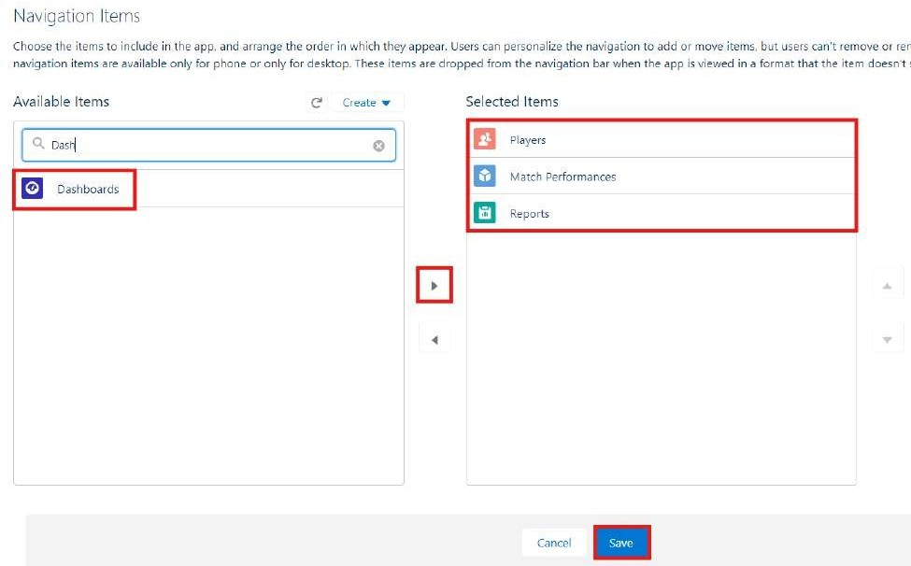

- To Add User Profiles : System Administrator

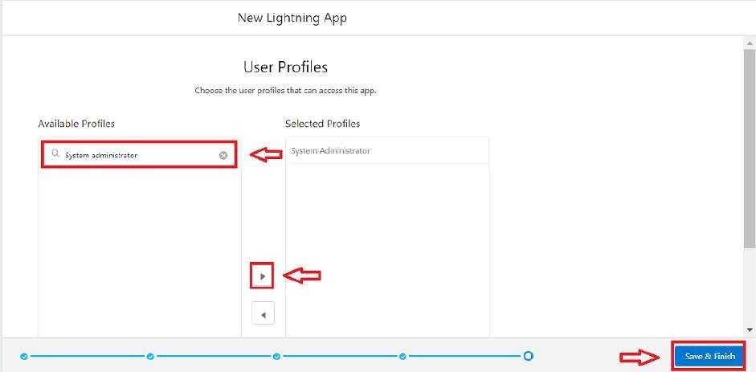

- Click Save & Finish.

Milestone 5 : Fields & Relationships

Activity 1 : Create Custom fields for Player object

- In your Salesforce org, click gear icon on the top left and select Setup to open Setup.
- Click the Object Manager tab. If you don’t see it, enter Object Manager in the Quick Find box.
- From the object manager page, In the Quick Find box, Search for the custom object you just created : Player
- From the sidebar, click Fields & Relationships. Notice that there are already some fields there. Those are the standard fields.
- Click New to create a custom field. Tip: Before creating a new field, do a quick search to make sure a similar one doesn’t already exist.
- Next, choose a data type as Text. Choosing a data type helps you format the field input.
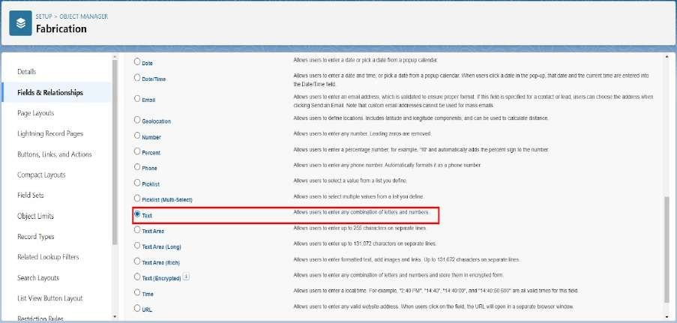

- Click on next.

- Data Type : Text
Field Label: Player Name Field Name : Auto Populates Length : 50
Click on Next → Next → Save and new.

- Repeat the Same steps for remaining fields

  - Data Type : Text
Field Label: Player Number Field Name : Auto Populates Length : 3
Click on Next → Next → Save and new.

  - Data Type : Rich Text Area Field Label : Profile Picture Field Name : Auto Populates
Click on Next → Next → Save and new.

  - Data Type : Date
Field Label : Date of Birth Field Name : Auto Populates
Click on Next → Next → Save and new.

  - Data Type : Picklist
Field Label : Role
Field Name : Auto Populates
Value : Enter value, with each value separated by a new line.
Batsman Bowler
Batsman & Wicket Keeper All Rounder

  - Data Type : Picklist
Field Label : Batting Style Field Name : Auto Populates
Value : Enter value, with each value separated by a new line.
Right- Handed Left - Handed
Click on Next → Next → Save and new.

  - Data Type : Picklist
Field Label : Bowling Style Field Name : Auto Populates
Value : Enter value, with each value separated by a new line.
Right-Arm Fast Left-Arm Fast

Right-Arm Medium Left-Arm Medium Right-Arm Spin Left-Arm Spin
Click on Next → Next → Save and new.

  - Data Type : Picklist
Field Label : Nationality Field Name : Auto Populates
Value : Enter value, with each value separated by a new line.
Australia Bangladesh England India
New Zealand Pakistan South Africa Sri Lanka West Indies Afghanistan Zimbabwe Ireland Scotland Netherlands
United Arab Emirates Nepal
United States of America
Click on Next → Next → Save and new.

  - Data Type : Picklist
Field Label : Team
Field Name : Auto Populates
Value : Enter value, with each value separated by a new line
Chennai Super Kings (CSK) Delhi Capitals (DC)
Kolkata Knight Riders (KKR) Mumbai Indians (MI)
Punjab Kings (PBKS) Rajasthan Royals (RR)
Royal Challengers Bangalore (RCB) Sunrisers Hyderabad (SRH)
Gujarat Titans (GT) Lucknow SuperGiants (LSG)

  - Data Type : Formula
Field Label : AVG Score Field Name : Auto Populates Formula Return : Number Formula : IF(
Matches_Played c > 0,
Total_Runs c / Matches_Played c , 0
)
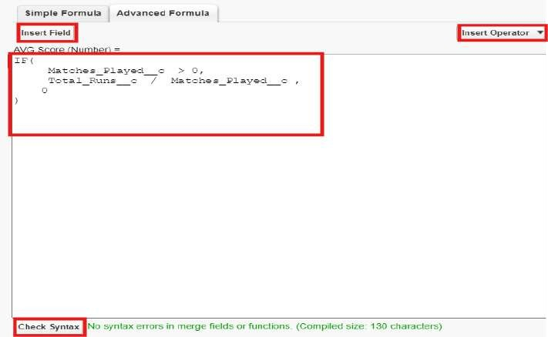
Click on Next → Next → Save & New.

  - Data Type : Lookup Relationship Related To : Match Performance Field Label : Match Performance Field Name : Auto Populates
Click on Next → Next → Save.

Activity 2 : Create Custom fields for Match Performance object.

- Data Type : Text
Field Label: Match Performance Name Field Name : Auto Populates
Length : 80
Click on Next → Next → Save and new.

- Data Type : Checkbox
Field Label: Player of the Match

Field Name : Auto Populates
Click on Next → Next → Save and new.

- Data Type : Picklist
Field Label: Match Result Field Name : Auto Populates
Value : Enter value, with each value separated by a new line
WON LOST DRAW
Click on Next → Next → Save and new.

- Data Type : Number
Field Label: Runs Scored Field Name : Auto Populates
Click on Next → Next → Save and new.

- Data Type : Number
Field Label: Balls Faced Field Name : Auto Populates
Click on Next → Next → Save and new.

- Data Type : Number
Field Label: Fours
Field Name : Auto Populates
Click on Next → Next → Save and new.

- Data Type : Number
Field Label: Sixes
Field Name : Auto Populates
Click on Next → Next → Save and new.

- Data Type : Number
Field Label: Overs Bowled Field Name : Auto Populates
Click on Next → Next → Save and new.

- Data Type : Number
Field Label: Wickets Taken Field Name : Auto Populates
Click on Next → Next → Save and new.

- Data Type : Number
Field Label: Runs Conceded Field Name : Auto Populates
Click on Next → Next → Save and new.

- Data Type : Number
Field Label: Maiden Overs Field Name : Auto Populates
Click on Next → Next → Save and new.

- Data Type : Number
Field Label: Stumpings
Field Name : Auto Populates
Click on Next → Next → Save and new

- Data Type : Number
Field Label: Catches
Field Name : Auto Populates
Click on Next → Next → Save and new.

- Data Type : Master - Detail Relationship
Related To : Player Field Label : Player
Field Name : Auto Populates Click on Next → Next → Save.

Milestone 6 : Roll-up Summary

Activity 1 : Create Roll-up Summary for Player object.

Note :- Roll-up Summary can only be created on parent object in Master- Detail Relationship.

- In your Salesforce org, click gear icon on the top left and select Setup to open Setup.
- Click the Object Manager tab. If you don’t see it, enter Object Manager in the Quick Find box.
- From the object manager page, In the Quick Find box, Search for the custom object you just created : Player

- From the sidebar, click Fields & Relationships. Notice that there are already some fields there. Those are the standard fields.
- Click New to create a custom field. Tip: Before creating a new field, do a quick search to make sure a similar one doesn’t already exist. Click Next,
- Choose a data type as Roll-up Summary. Click Next. Field Label: Matches Played
Field Name : Auto Populates
Summarized Object : Match Performances Select Roll-up Type : COUNT
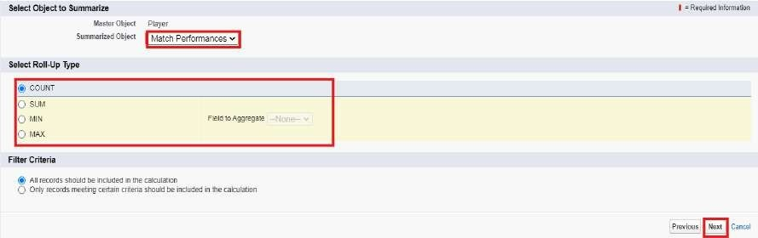

Filter Criteria : All records should be included in the calculation. Click on Next → Next → Save and new.

  - Data Type : Roll-up Summary Field Label: Number of 50’s Field Name : Auto Populates
Summarized Object : Match Performances Select Roll-up Type : COUNT
Filter Criteria : Only records meeting certain criteria should be included in the calculation.
Click on Next → Next → Save and new.
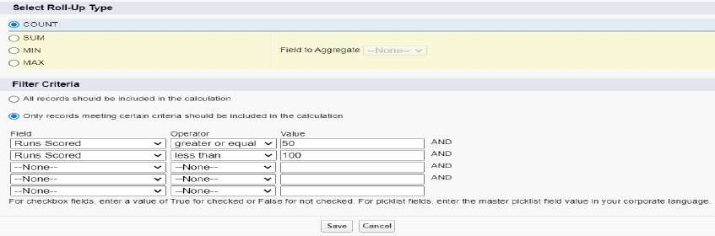

  - Data Type : Roll-up Summary Field Label: Number of 100’s Field Name : Auto Populates
Summarized Object : Match Performances Select Roll-up Type : COUNT
Filter Criteria : Only records meeting certain criteria should be included in
the calculation.
Click on Next → Next → Save and new.
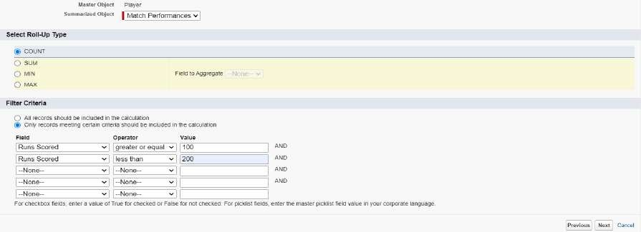

  - Data Type : Roll-up Summary Field Label: Total 4’s
Field Name : Auto Populates
Summarized Object : Match Performances Select Roll-up Type : SUM
Field To Aggregate : Fours
Filter Criteria : All records should be included in the calculation. Click on Next → Next → Save and new.

  - Data Type : Roll-up Summary Field Label: Total 6’s
Field Name : Auto Populates
Summarized Object : Match Performances Select Roll-up Type : SUM
Field To Aggregate : Sixes
Filter Criteria : All records should be included in the calculation. Click on Next → Next → Save and new.

  - Data Type : Roll-up Summary Field Label: Total Runs
Field Name : Auto Populates

Summarized Object : Match Performances Select Roll-up Type : SUM
Field To Aggregate : Runs Scored
Filter Criteria : All records should be included in the calculation. Click on Next → Next → Save and new.

  - Data Type : Roll-up Summary Field Label: Total Overs
Field Name : Auto Populates
Summarized Object : Match Performances Select Roll-up Type : SUM
Field To Aggregate : Overs Bowled
Filter Criteria : All records should be included in the calculation. Click on Next → Next → Save and new.

  - Data Type : Roll-up Summary Field Label: Total Wickets Field Name : Auto Populates
Summarized Object : Match Performances Select Roll-up Type : SUM
Field To Aggregate : Wickets Taken
Filter Criteria : All records should be included in the calculation. Click on Next → Next → Save and new.
  - Data Type : Roll-up Summary Field Label: Total Stumpings Field Name : Auto Populates
Summarized Object : Match Performances Select Roll-up Type : SUM
Field To Aggregate : Stumpings
Filter Criteria : All records should be included in the calculation. Click on Next → Next → Save and new.
  - Data Type : Roll-up Summary Field Label: Total Catches Field Name : Auto Populates
Summarized Object : Match Performances Select Roll-up Type : SUM
Field To Aggregate : Catches
Filter Criteria : All records should be included in the calculation. Click on Next → Next → Save and new.

Milestone 7 : Flows Activity 1 : Screen Flow
- Go to setup, Type Flow in quick find box → Click on the Flow and Select the New Flow.
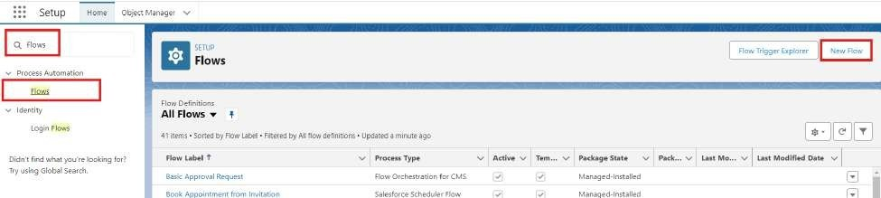

- Select Screen Flow and click Create.
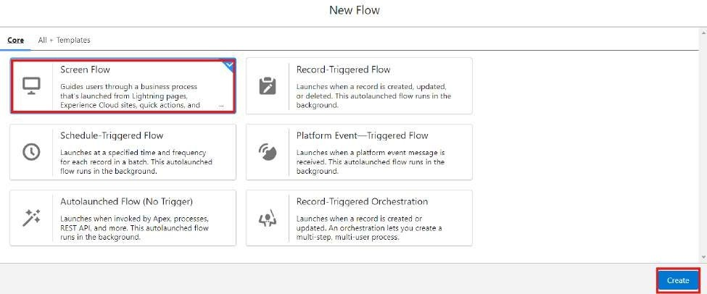

- Click (+) Icon on the flow builder and Select Screen Component. Label : Players screen
API : Players_screen
Select the Picklist component and place it on the screen.
Label : Team
API : Team
From Component Pane on the left side select Component Type : Picklist
Data Type : Text
Choice : Click New Choice Resources

Resource Type : Picklist Choice Set

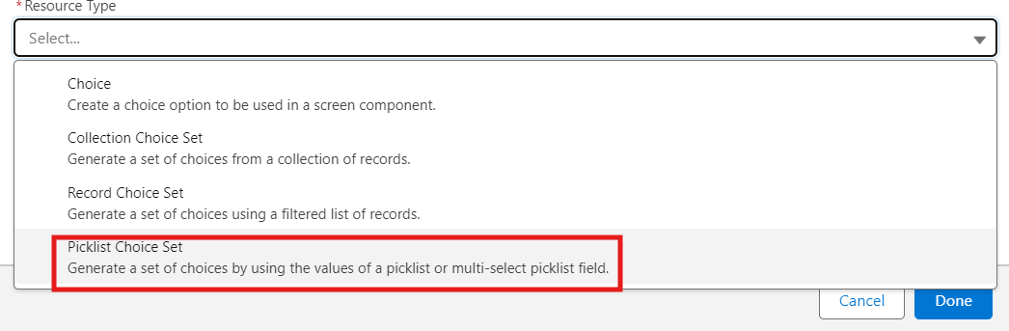

API Name : Team Object : Player Data Type : Picklist Field : Team
Click Done.
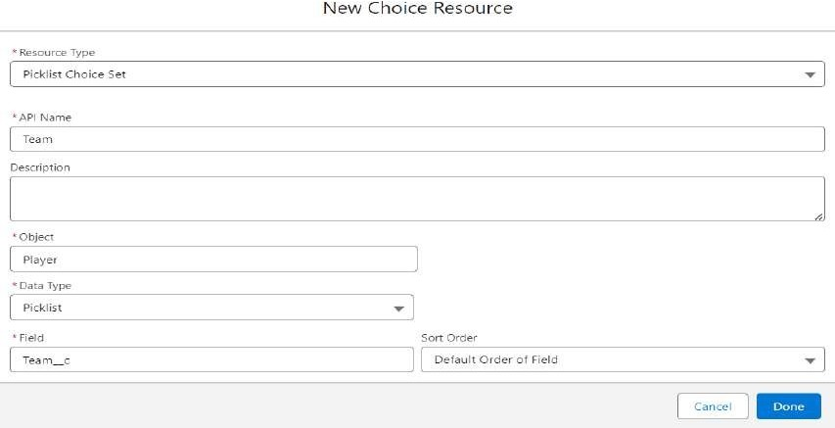

- Click (+) Icon on the flow builder and Select Get Records Component. Label : Players
API Name : Players
Object : Player
Filter player records : Field : Team Operator : Equals

Value : Click New Resource Resource Type : Variable API Name : Dynamic
Data Type : Text
Default Value : Screen component : Team (Picklist)
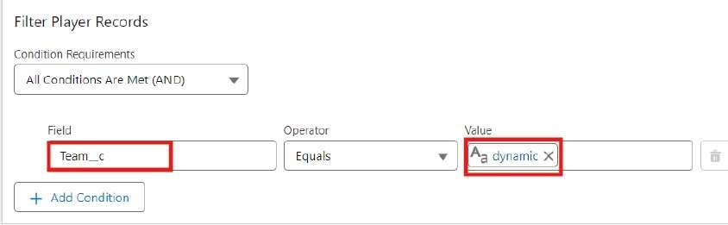

- Click (+) Icon on the flow builder and Select Screen Component. Label : Player_info
API Name : Player_info
From Component Pane on the left side select Component Type : Data table
API Name : Player_info_table
Label : Data Table
Configure Data Source : Source Collection : Players from players (Player c)
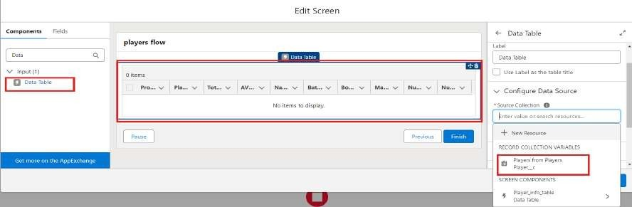

In Configure Columns : Add all the required Columns
Profile Picture | Player Name | Total Runs | AVG Score | Batting Style | Bowling Style | Matches Played | Number of 50’s | Number of 100’s
Click Done.

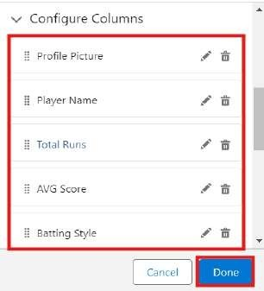
Click Save.
Flow Label : Player Flow
Flow API Name : Player_Flow
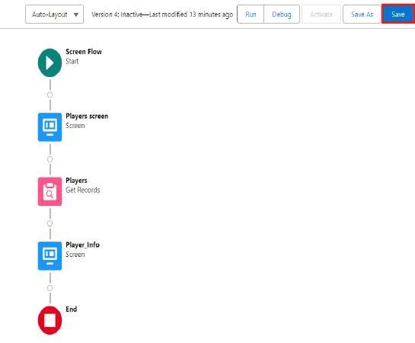

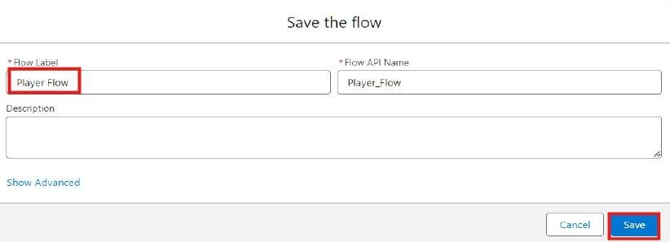

Activity 2 : Flow on Home Page

- On your CRICKSTATS Application on the top right of the Navigation Bar click on
Personalize your nav bar icon (Pencil Icon) and Add Home Page and click Save.
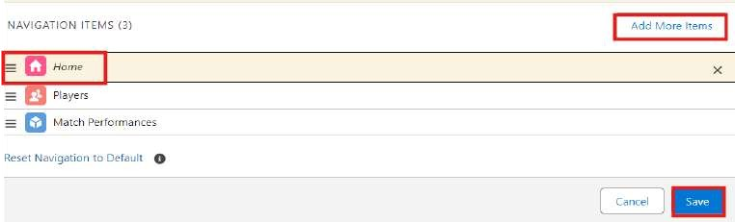

- Remove all other components and Add FLOW component from the standard components on the left side.
- Flow : Players Flow
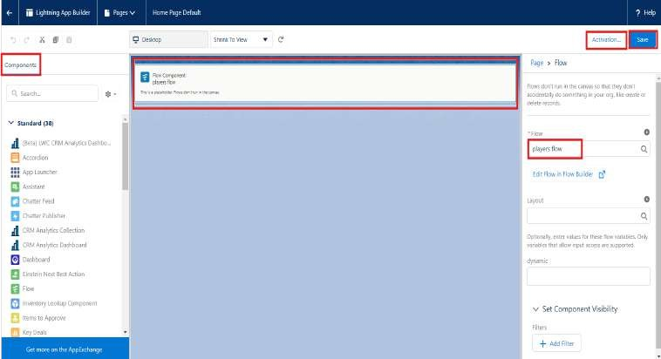

- Click Save and Activation.
- Click on App Default and select Assign to Apps.
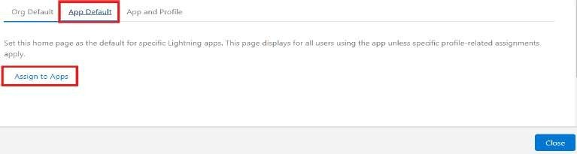

- Select CRICKSTAS App and Click Next and then click Save.
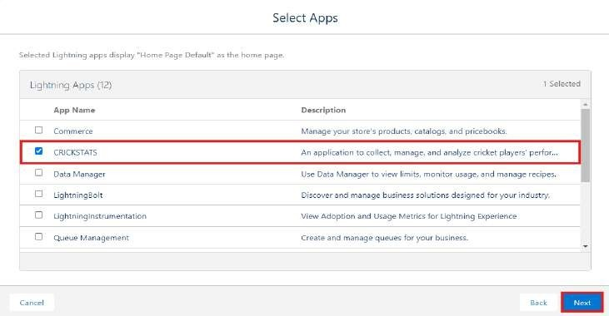

FUNCTIONAL & PERFORMANCE TESTING

During the testing phase, screenshots were captured from the Salesforce Lightning user interface to verify the correct functioning of all implemented features in the CRICKSTATS system. These include record creation for Player and Match Performance objects; validation rule checks for mandatory fields, score limits, and input constraints; verification of record type behavior for Domestic and International match categories; and flow execution for automatic updating of player statistics and data consistency. The functionality of roll-up summary fields was also tested to ensure accurate calculation of total runs, wickets, averages, and performance metrics.

In addition, system performance was evaluated by monitoring response time during data entry, report generation, and dashboard loading. The application was tested under multiple user interactions to ensure stable performance without delays. Screenshots of generated reports and interactive dashboards were documented to confirm accurate data visualization, real-time updates, and reliable performance tracking. These testing

activities ensured that the CRICKSTATS platform met both functional and performance requirements and was ready for deployment.

NOTE : Enter some records in the Player Object and Match Performance Object to get the results.

  - Select one Team from the Picklist and Click Next.
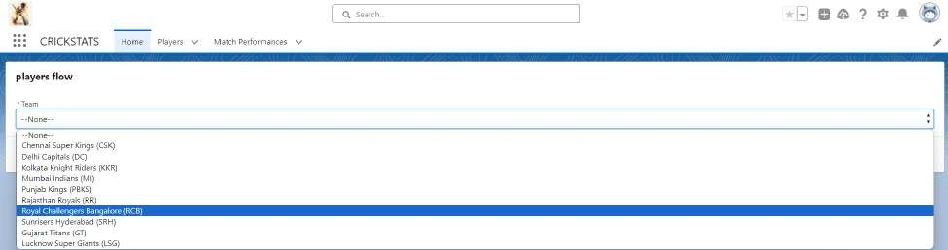
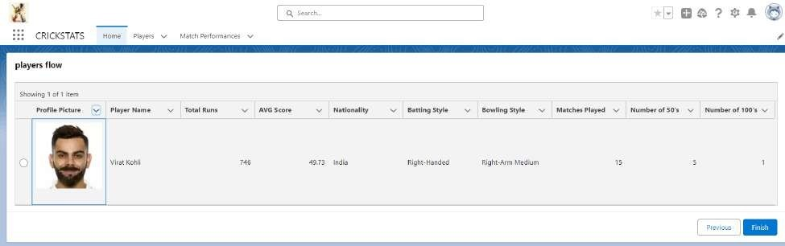
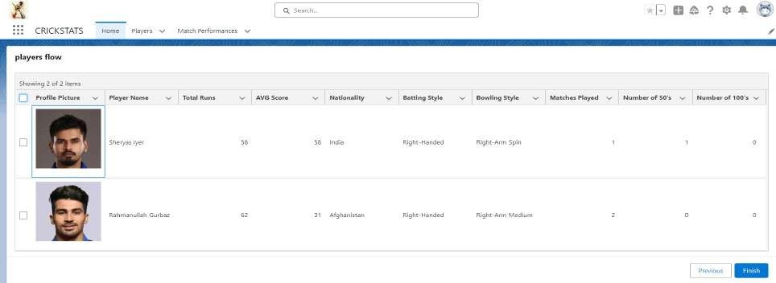

ADVANTAGES & DISADVANTAGES

Advantages

- Centralized system
- Real-time analytics
- Secure platform
- Scalable design
- Reduced manual work

Disadvantages

- Requires Salesforce license
- Internet dependency
- Limited offline access

Conclusion:

CRICKSTATS successfully implements a cloud-based cricket performance tracking system using Salesforce. The system automates data management, improves reporting accuracy, and supports informed decision-making.

The project demonstrates practical application of SDLC, Agile methodology, and CRM-based development.

FUTURE SCOPE
- Mobile application integration
- AI-based performance prediction

- Video analysis integration
- Player ranking system
- Public statistics portal
- Multi-league support

APPENDIX
- Salesforce Objects & Fields
- Manual match statistics
- Flow Configurations

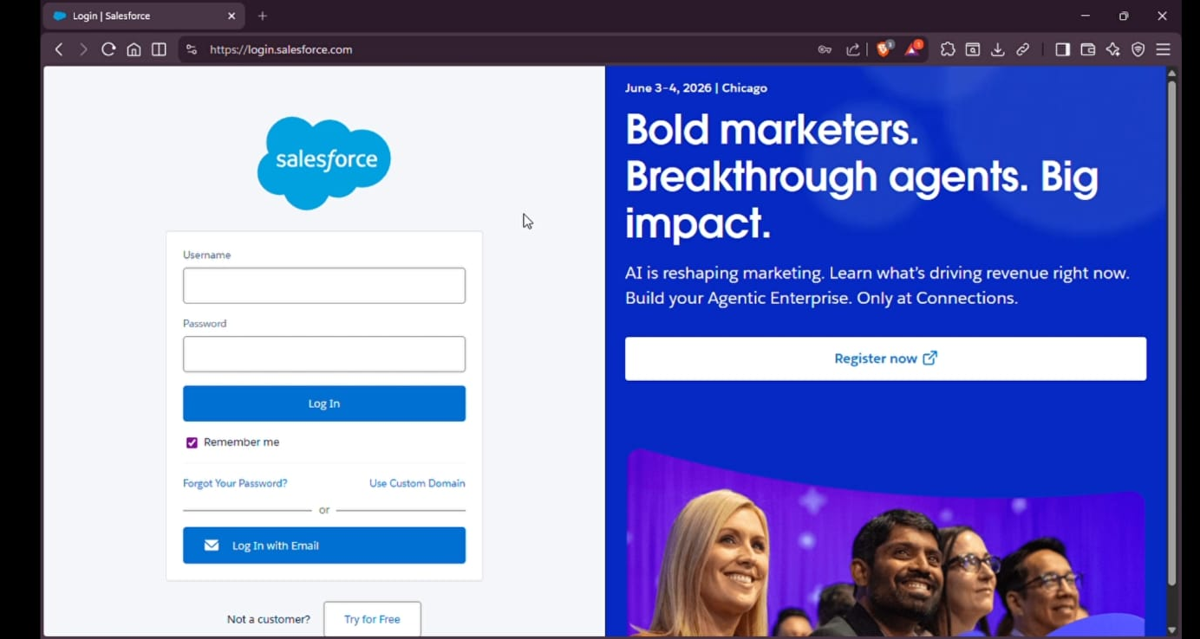

Salesforce Login:

“This image shows the Salesforce login page used to access the Cricket Statistics system.”
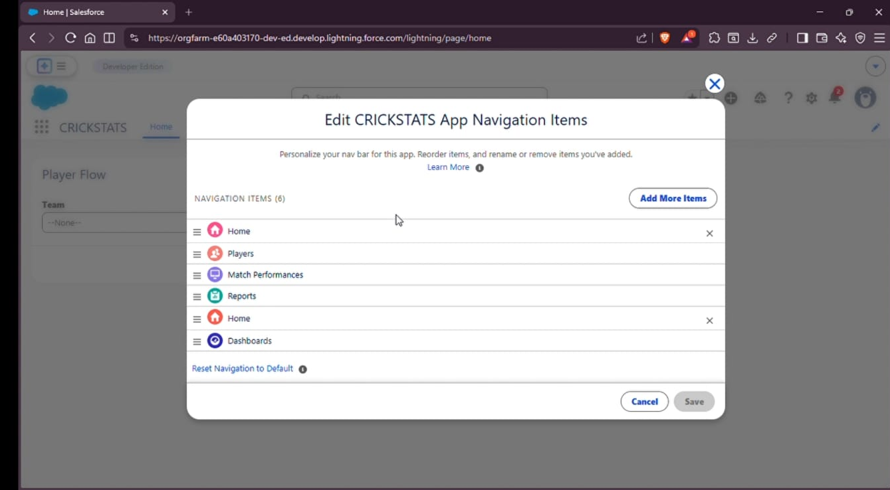

New Match Performance:

“This screen is used to enter and save match performance details such as runs, balls, fours, and sixes.”

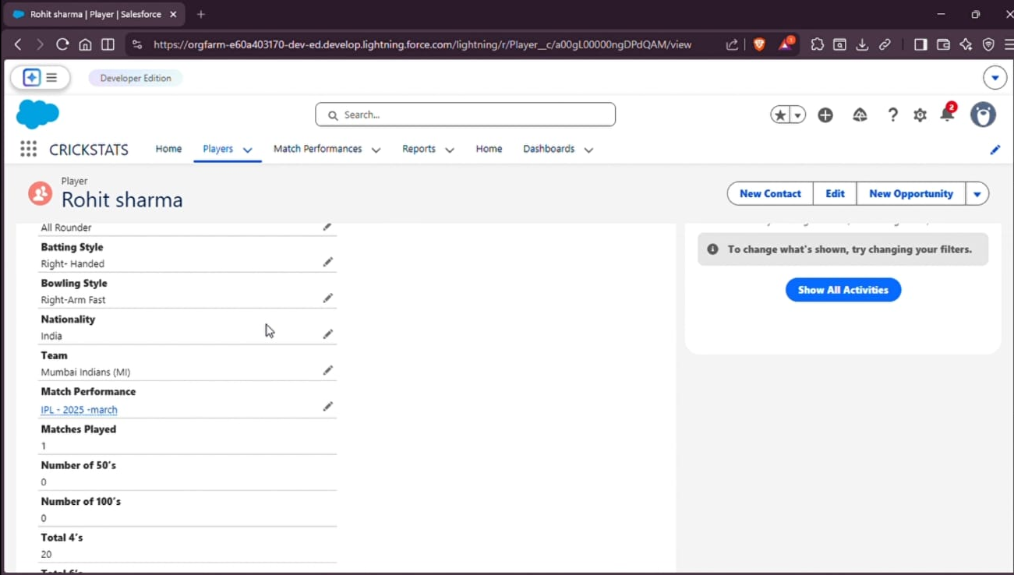

Navigation Items:

“This screen shows the customized Salesforce navigation menu for accessing different system modules.”
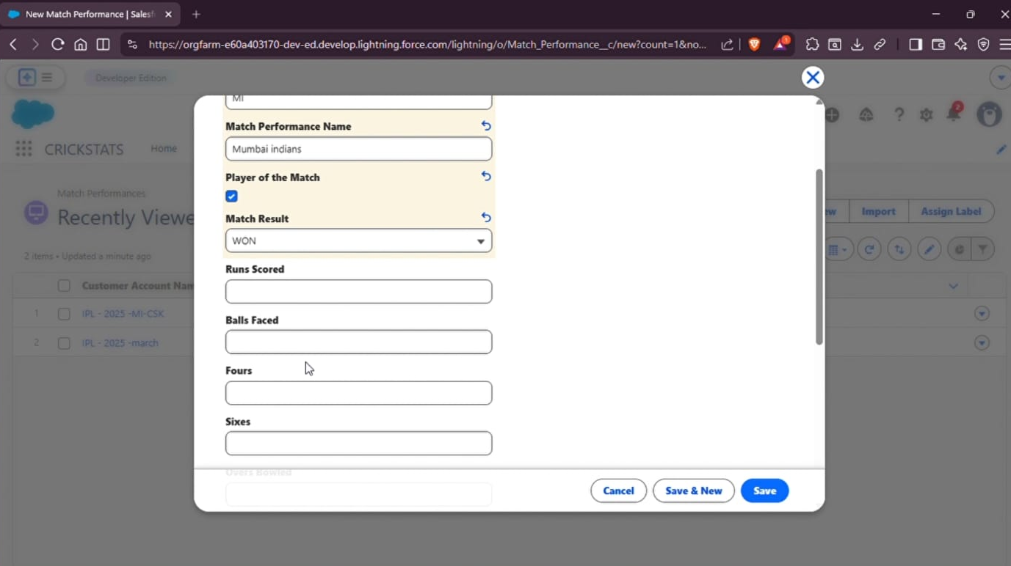

Player Details:
“This page displays a player’s profile, team, playing style, nationality, and performance statistics.”
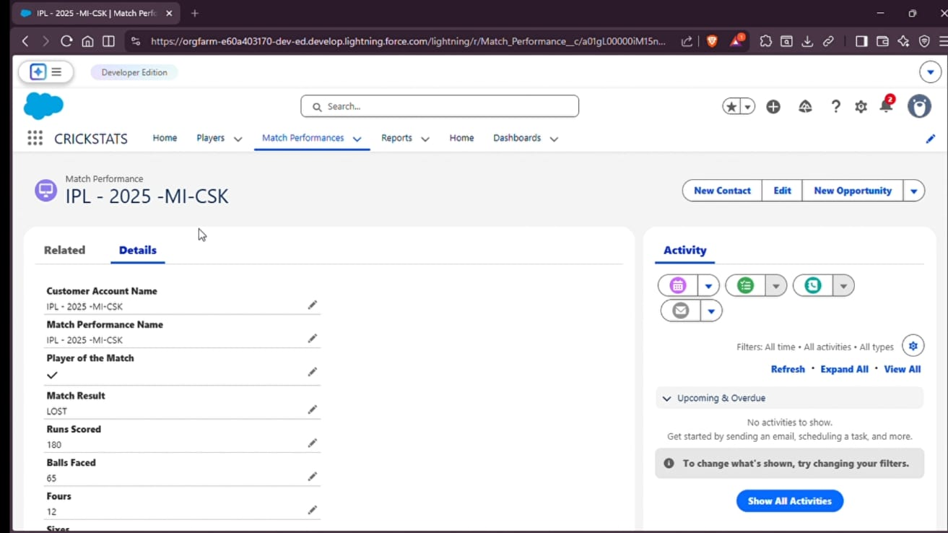

Match Performance List:
“This screen displays the list of recorded cricket match performances in the system.”
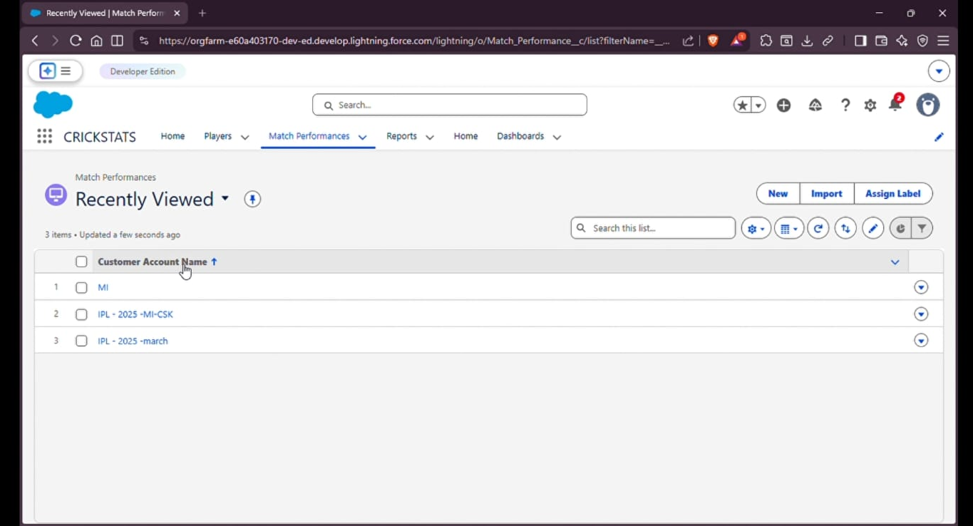

Match Performance Details:
“This page shows complete details of a selected match, including result and batting performance.”
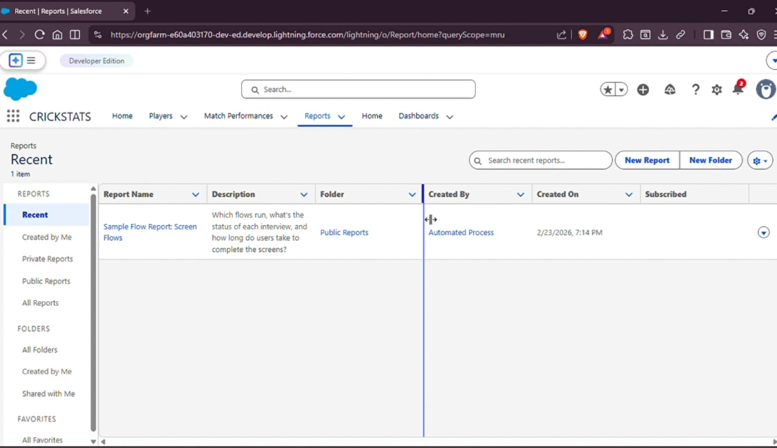

Reports:
“This screen provides access to reports generated from the Salesforce cricket management system.”
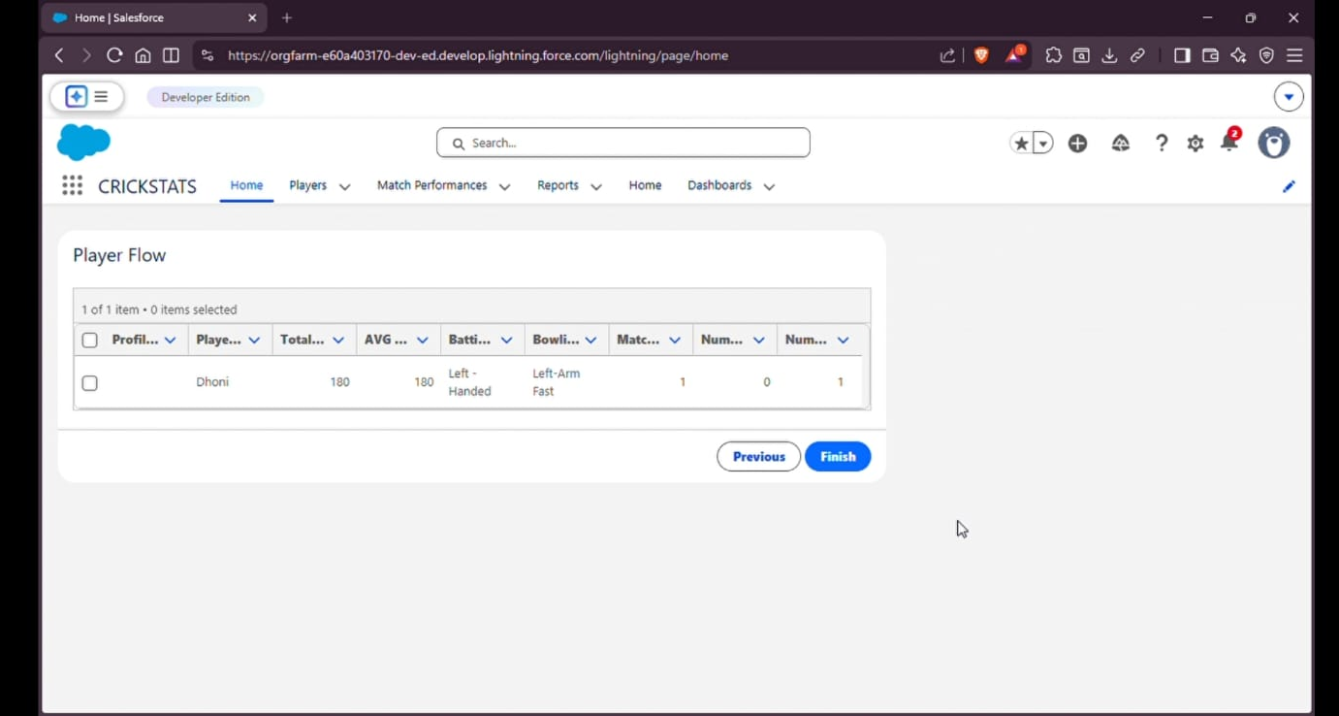

Player Flow – Team Selection:
“This flow allows users to select a team and view the players associated with it.”
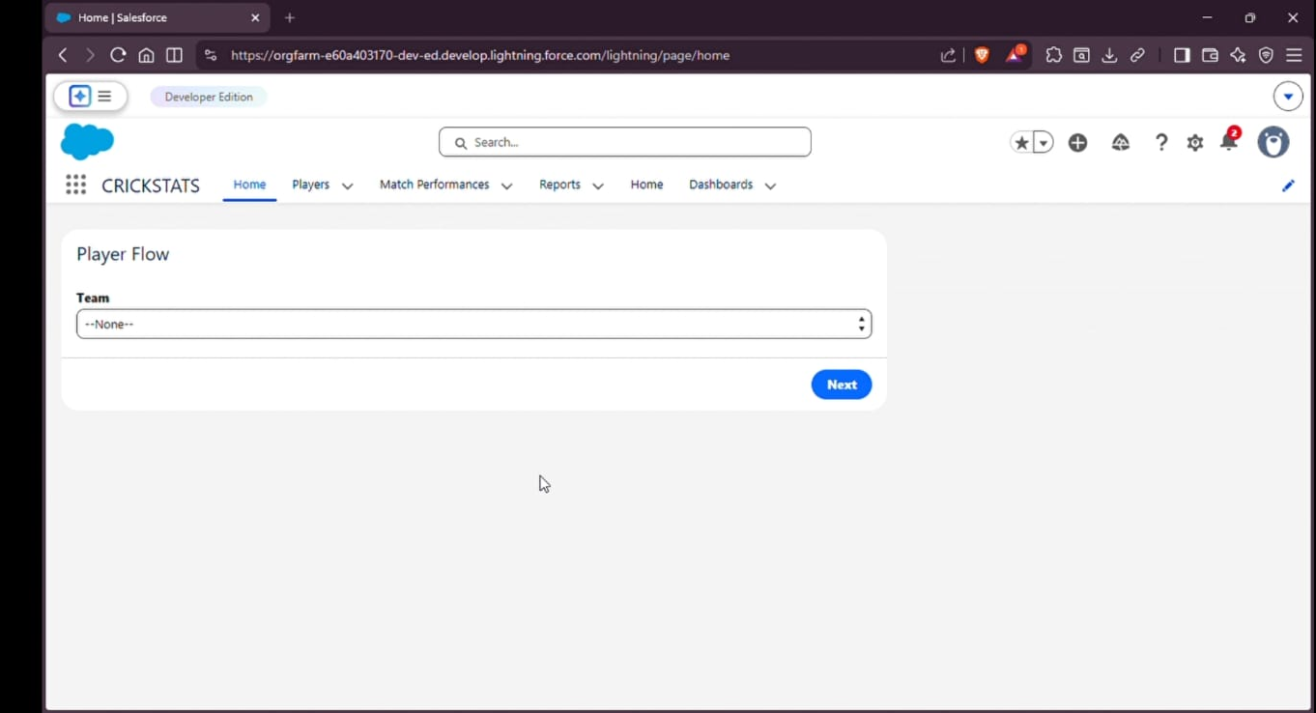

Player Flow – Results:
“This screen displays the selected player’s performance statistics based on the chosen team.”

